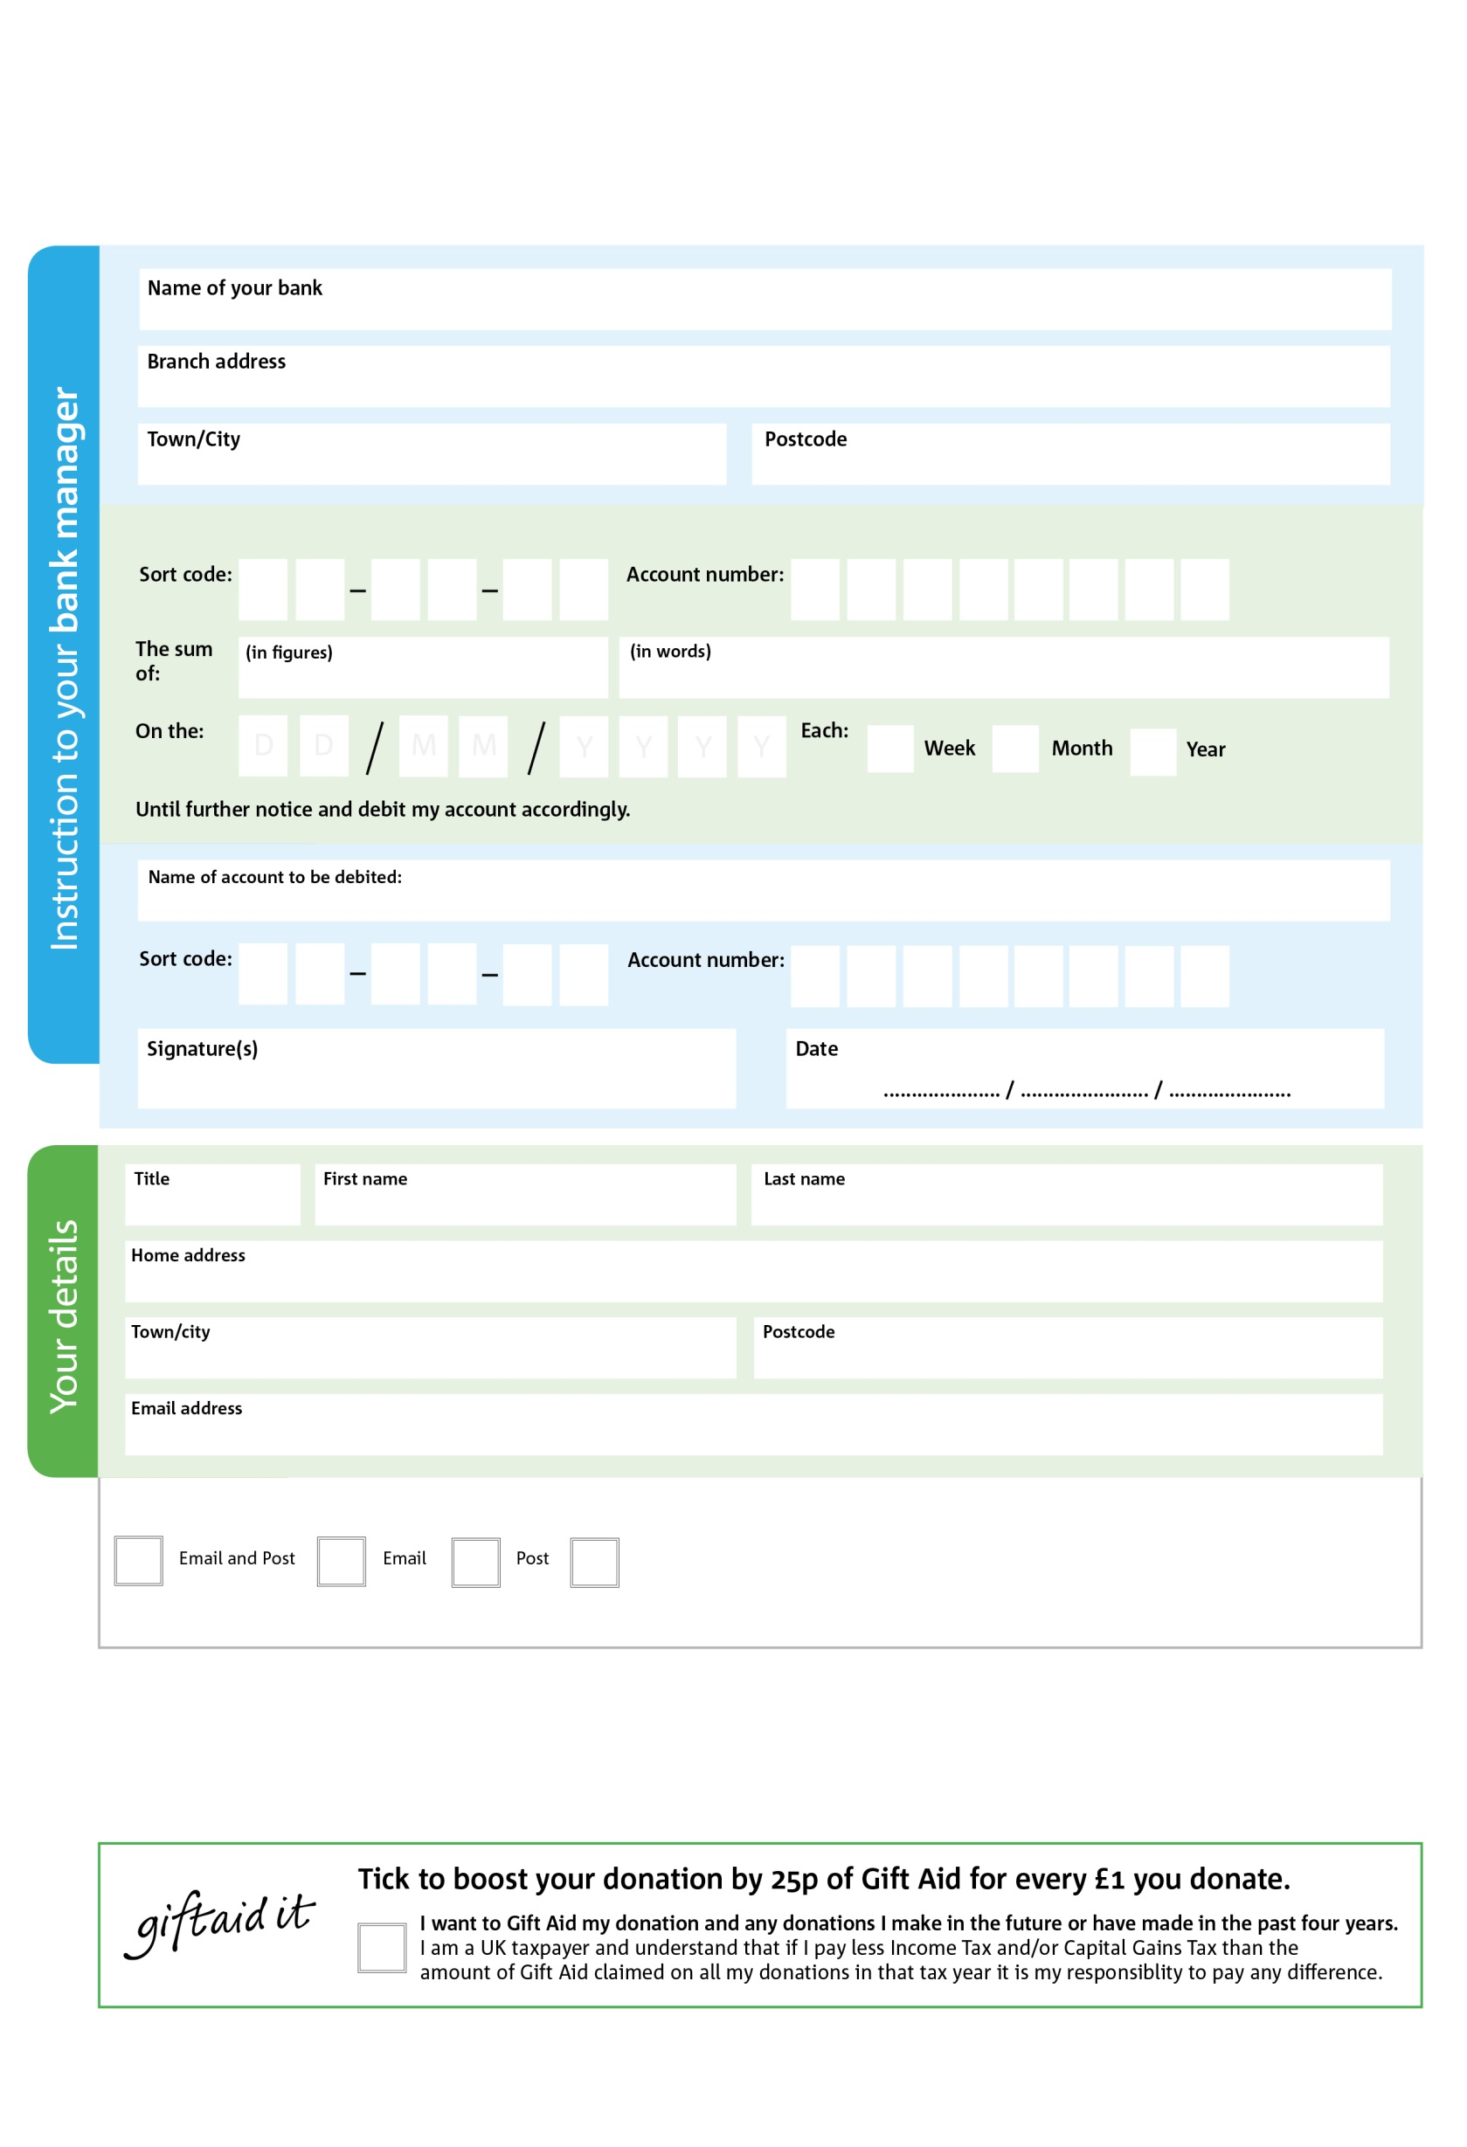

Coventry Foodbank in partnership with Feed the Hungry

Feed the Hungry UK is a company limited by guarantee registered in England & Wales (5537293) and a charity registered in England and Wales (1112955).

Registered Office: Charnwood House, Harcourt Way, Meridian Business Park, Leicester, LE19 1WP

**Data protection**

*'Coventry Foodbank is committed to protecting your privacy and will process your personal data in accordance with current Data Protection legislation. Coventry Foodbank collects information to keep in touch with you and supply you with information relating to our work. To unsubscribe from our newsletter, send a message to the email address above with the word unsubscribe in the subject line. A full data privacy statement for financial donors is available from the foodbank on request.’*

POSTAL ADDRESS: Coventry Foodbank, Progress Way, Binley, Coventry, CV3 2NT

You can change your preferences any time by contacting us on 02476 993770 or emailing us at info@Coventry.Foodbank.org.uk

I do not wish to receive future communications from Coventry Foodbank

We would love to keep you up to date with information about Coventry Foodbank. Please tick your preference:

**Standing Order Mandate**

**Coventry.foodbank.org.uk**

**Please pass this form onto the foodbank, using the foodbank’s address at the bottom, who will save a copy for their records.   
They will then send it onto your named bank or building society. All donations will be used to fund the work of Coventry Foodbank.**

6

V

0

V

7

V

3

V

7

V

8

V

3

V

0

V

5

5

1

6

0

2

Please pay Coventry Foodbank,

You can change your preferences any time by contacting us on XXXXXXXXXXX or emailing us at XXXX@XXXXXXXXXX.foodbank.org.uk

I do not wish to receive future communications from XXXXXX Foodbank